**F. Y. B. Tech Academic Year 2021-22**

**Subject:** Basics of Electrical and Electronics Engineering **Trimester:** II

**Name:** Shreerang Mhatre **Division:** 11

**Roll No:** 111056  **Batch:** K3

**Experiment No: 2**

**Name of the Experiment**: Design of half wave rectifier using PN junction diode.

**Performed on: 17/12/2021**

**Submitted on: 27/12/2021**



**Aim: Design of half wave rectifier using pn junction diode.**

**Prerequisite:**

* Basic knowledge of diode and rectifier, capacitor filter.

**Objectives:**

* To study the operation of Half- Wave Rectifier with and without filter and to find its ripple factor
* To measure voltages and observe waveforms at output of rectifier.

**Components and equipment required:**

|  |  |  |
| --- | --- | --- |
| **S.No.** | **Name** | **Quantity** |
| 1 | Bread board | 1 (One) No. |
| 2 | Diodes (1N4007) | 1 (One) No. |
| 3 | Resistor (1Khttp://i.imgur.com/6fz6IHX.gif/2.2 Khttp://i.imgur.com/6fz6IHX.gif) | 1 (One) No. |
| 4 | Capacitor 100http://i.imgur.com/YoyOvED.gifF/4.7http://i.imgur.com/YoyOvED.gifF | 1 (One) No. |

**Equipment:**

Function generator, CRO, DMM, 1N4007 rectifier diode, capacitors, connecting wires etc.

**Theory:**

**Components of DC Power Supply:**

The DC power supply converts the standard ac voltage (230V, 50Hz) into a constant DC voltage. The DC voltage produced by a power supply is used to power all types of electronic circuits, such as television, VCRs, CD players and most of the laboratory equipment. The simplest and most common type of DC power supply is a ‘linear’ system. The block diagram of a typical linear power supply is shown schematically in Fig. 5.1. AC voltage is applied to a transformer, which steps it down to the level for the desired dc output. Output of the transformer is applied to a diode rectifier which provides a full-wave rectified voltage. This voltage is filtered by a simple capacitor filter to produce a dc voltage. This resulting dc voltage usually has some ripple or AC voltage variation. To remove this ripple, a regulator circuit is used. This regulator provides a constant DC voltage at the output despite changes in the input or the load current.

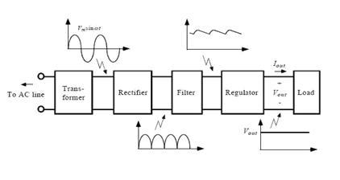

**Fig 5.1: Components of a typical linear power supply**

**pn junction diode as a rectifier:**

A rectifier is an electronic device that converts AC voltage into DC voltage. A rectifier is used in almost all electronic devices. Mostly it is used to convert the main voltage into DC voltage in the [power supply](https://www.elprocus.com/types-power-supplies/) section. By using DC voltage supply electronic devices work. According to the period of conduction, rectifiers are classified into two categories: Half Wave Rectifier and [Full Wave Rectifier](https://www.elprocus.com/full-wave-rectifier-circuit-working-theory/).

### **Working of a Half-Wave Rectifier**

During the positive half cycle, when the input is positive, the diode is under forward bias condition and it conducts current. During the positive half cycles, the input voltage is applied directly to the load resistance when the forward resistance of the diode is assumed to be zero. The wave forms of output voltage and output current are same as that of the AC input voltage. During the negative half cycle, the diode is under reverse bias condition and it does not conduct current. During the negative half cycle, the voltage and current across the load remains zero. The magnitude of the reverse current is very small and it is neglected. So, no power is delivered during the negative half cycle.

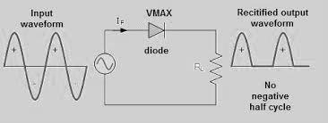

**Fig 5.2** **Half wave rectifier without filter**

Since the diode conducts only in one half-cycle (0-π), it can be verified that the d.c. component in the output is ***Vmax/π,*** where ***Vmax*** is the peak value of the voltage. Thus,

(5.1)

(5.2)

***AC or RMS LOAD CURRENT ():***

(5.3)

***AC or RMS LOAD VOLTAGE (VLrms):***

(5.4)

The current flowing through the resistor and power consumed by the load,

(5.5)

*R* (5.6)

***Ripple factor:***

As the voltage across the load resistor is only present during the positive half of the cycle, the resultant voltage is "ON" and "OFF" during every cycle resulting in a low average dc value. This variation on the rectified waveform is called "**Ripple**" and is an undesirable feature. The ripple factor is a measure of purity of the d.c. output of a rectifier and is defined as

The **ripple factor** **without** (theoretical) **filter**:

(5.7)

The ripple factor with (theoretical) filter:

(5.8)

The ripple (practical) factor:

=Vrrms/VLDC (5.9)

##### ***Rectification Efficiency:***

Rectification efficiency, ***η***, is a measure of the percentage of total a.c. power input converted to useful dc power output. Here *rd* is the forward resistance of diode. Under the assumption of no diode loss (*rd*<<), the rectification efficiency in case of a half-wave rectifier is approximately 40.5%.

##### η = d .c. power delivered to load a.c. power at input

(5.10)

(5.11)

***η = Pdc / Pac = 0.406 ----- RL >> Rs + Rf*** (2.12)

***% η = 40.6%***

***Peak Inverse Voltage (PIV):***

**PIV**- the maximum value of reverse voltage,occurs at the peak of each negative alternation of the input voltage when the diode is reverse biased.

**PIV** for HWR is **Vp(in) or *Vm***

***Determining the required PIV rating of HWR:***

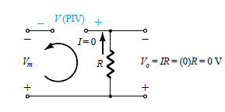 

**Fig.5.3 PIV of Half wave rectifier**

##### ***Filters:***

The output of a rectifier gives a pulsating d.c. signal (Fig.5.2) because of presence of some a.c. components whose frequency is equal to that of the a.c. supply frequency. Very often when rectifying an alternating voltage we wish to produce a "steady" direct voltage free from any voltage variations or ripple. Filter circuits are used to smoothen the output. Various filter circuits are available such as shunt capacitor, series inductor, choke input LC filter and π-filter etc. Here we will use a simple **shunt capacitor** filter circuit (Fig.5.4). Since a capacitor is open to d.c. and offers a low impedance path to a.c. current, putting a capacitor across the output will make the d.c. component to pass through the load resulting in small ripple voltage.

The working of the capacitor can be understood in the following manner. When the rectifier output voltage is increasing, the capacitor charges to the peak voltage ***Vm.*** Just past the positive peak the rectifier output voltage tries to fall. As the source voltage decreases below ***Vm,*** the capacitor will try to send the current back to the diode making it reverse biased. Thus the diode separates/disconnects the source from the load and hence the capacitor will discharge through the load until the source voltage becomes more than the capacitor voltage. The diode again starts conducting and the capacitor is again charged to the peak value ***Vm*** and the process continues. Although in the output waveform the discharging of capacitor is shown as a straight line for simplicity, the decay is actually the normal exponential decay of any capacitor discharging through a load resistor. The extent to which the capacitor voltage drops depends on the capacitance and the amount of current drawn by the load; these two factors effectively form the RC time constant for voltage decay. A proper combination of large capacitance and small load resistance can give out a steady output.

**Circuit Diagram:**

**Half Wave Rectifier (without filter):**

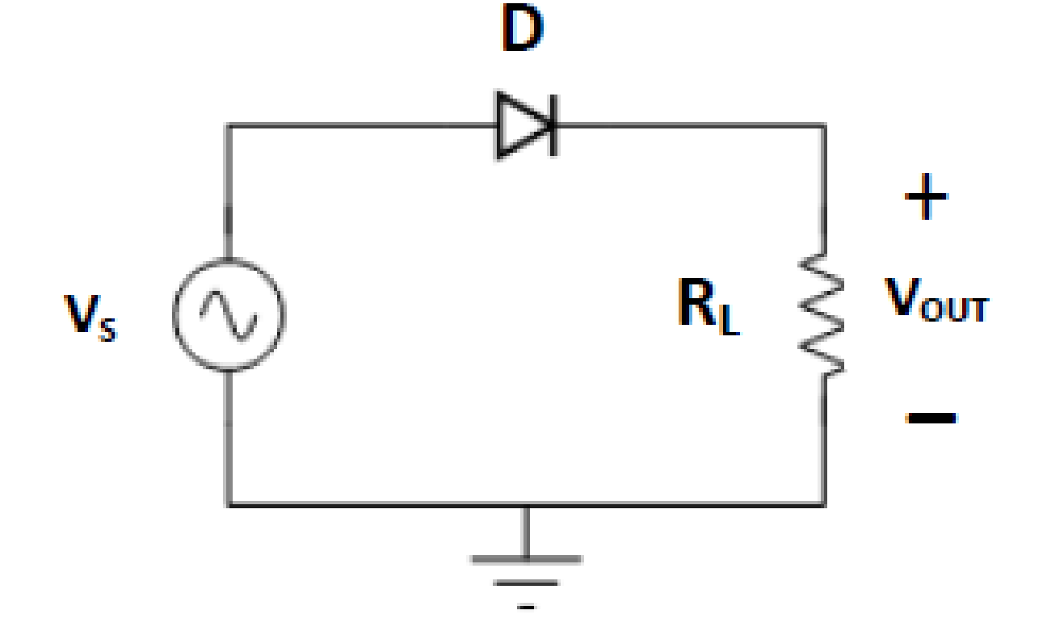

**Fig.5.4 Half-wave rectifier circuit**

**Half Wave Rectifier (with filter):**

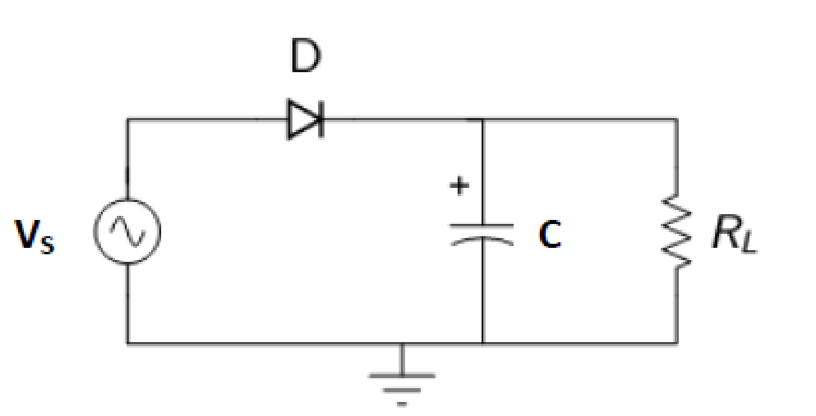

**Fig.5.5Half -wave rectifier circuit with capacitor filter**

**Procedure:**

* 1. Make the connection as per the circuit diagram shown in fig. 5.4 & 5.5
  2. Note down the voltage which is the unregulated input voltage.
  3. Observe unregulated output voltage at the output of the rectifier and filter.
  4. Observe the waveform at load resistor and capacitor filter.

**Observations:**

Input Voltage (***Vm***) =------V

**Specifications of components used:**

1. **Diode Selection (Not applicable as we are using Virtual diode (Tinkercad)**

***VLdc*** = ------V

***PIV***= ------V

***ILdc=IF= VLdc/Rf+RL***= -------mA

Therefore ------------------diode is selected.

1. **Load resistance RL= -------**
2. **Filter Capacitor C= -------**

**Expected Waveforms: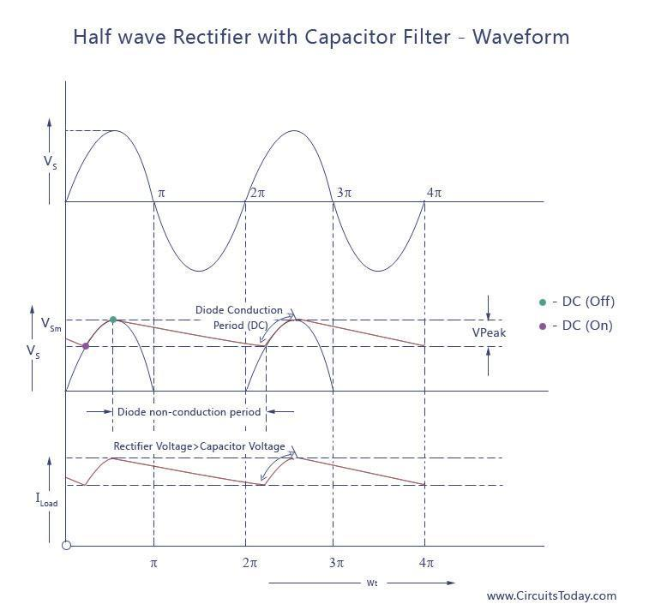Fig.5.6 Waveform of Half wave rectifier and filter**

**Observation Table:**

#### **Half wave rectifier without filter**

|  |  |  |  |  |  |
| --- | --- | --- | --- | --- | --- |
| **Sr. no**. | **Values / Quantities** | ***Vm*** | ***VLdc*** | ***Vrms*** | ***ILdc*** |
| 1 | Theoretical | 5V | 1.59V | 2.5 | 1.59 |
| 2 | Practical | 4.5V | 1.50V | 2.1 | 1.50 |

**Half wave rectifier with Capacitor filter**

|  |  |  |  |  |  |
| --- | --- | --- | --- | --- | --- |
| **Sr. no.** | ***C(***μF) | **Values / Quantities** | ***Vrpp*** | ***VLdc*** | ***ILdc*** |
| 1 | **C1=10** | Theoretical | 0.2 | 4.28 | 4.28 |
| Practical | 0.2 | 4.28 | 4.28 |
| 2 | **C2=1000** | Theoretical | 0.1 | 4.25 | 4.25 |
| Practical | 0.1 | 4.25 | 4.25 |

**Result:**

|  |  |  |  |  |  |
| --- | --- | --- | --- | --- | --- |
| **Ripple factor without filter** | | **Ripple factor with filter** | | | |
| **With Capacitor C1** | | **With Capacitor C2** | |
| Theoretical | Practical | Theoretical | Practical | Theoretical | Practical |
| 0.57 | 0.57 | 0.0472 | 0.0472 | 0. 368 | 0.368 |

**Note: Students are instructed to do all the necessary calculations on separate sheets.**

**Conclusion:**

In the given experiment we studied the operation of half wave rectifier with and without filter. We also found its ripple factor and measured voltages and observed waveforms at output of rectifier.

**C**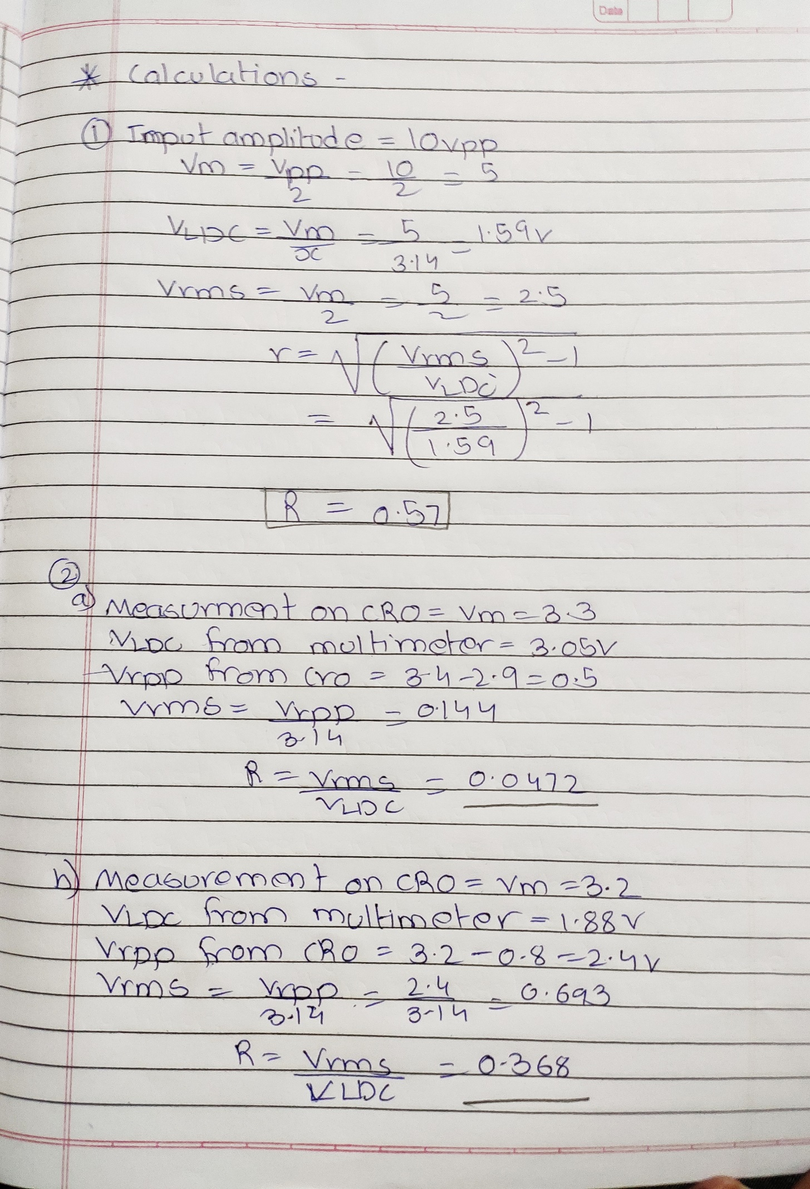

**Half Wave Rectifier without Filter:**

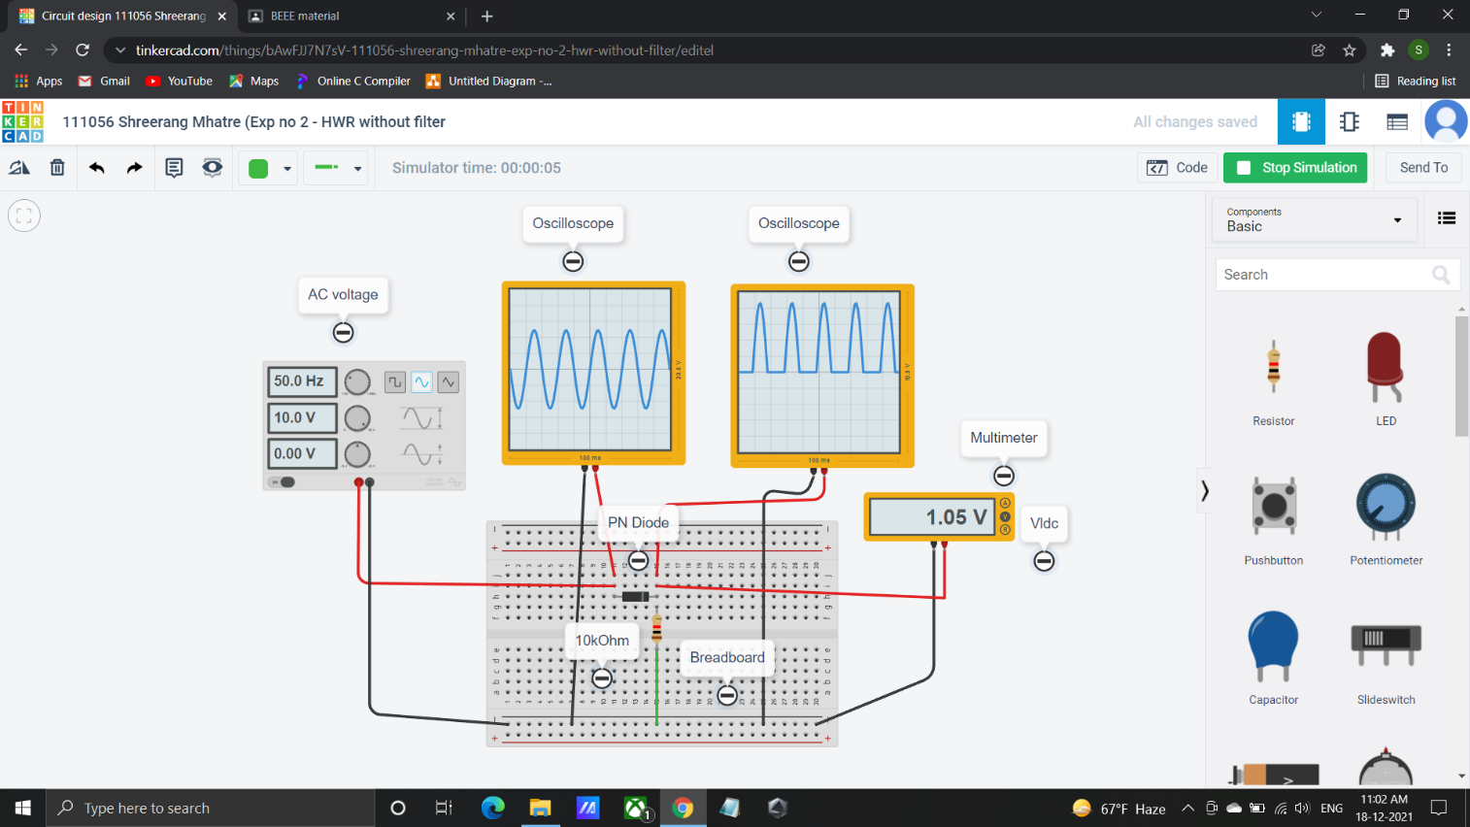

**Half Wave Rectifier with Filter:**

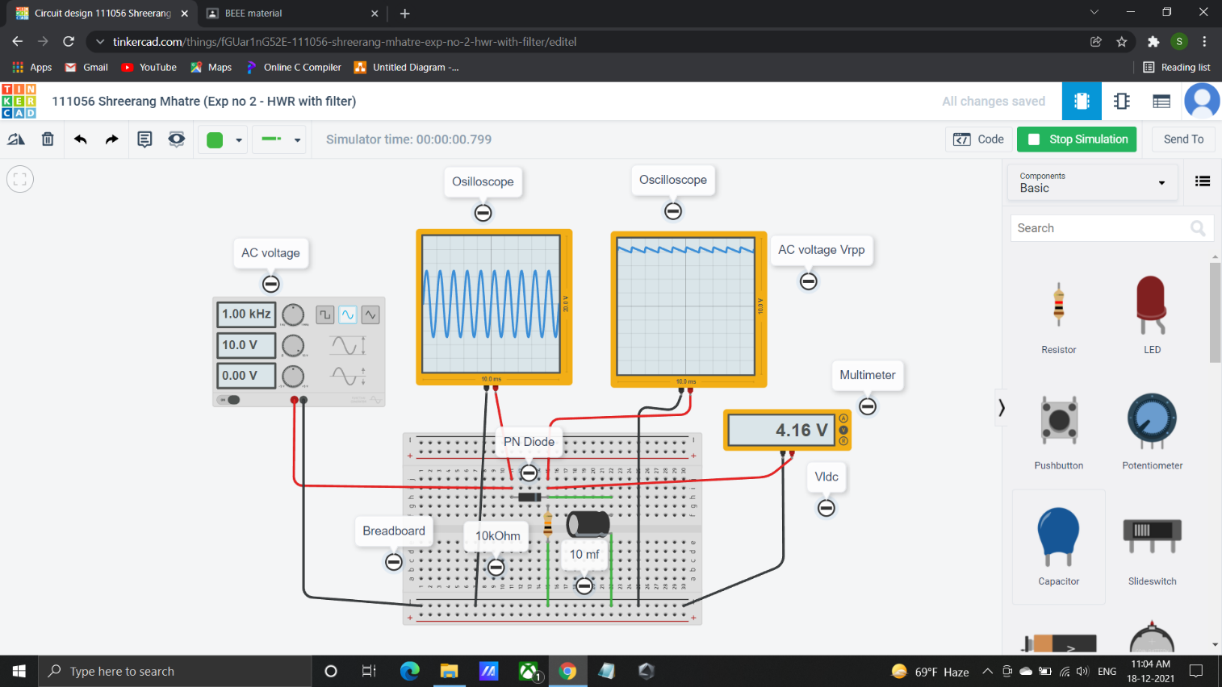

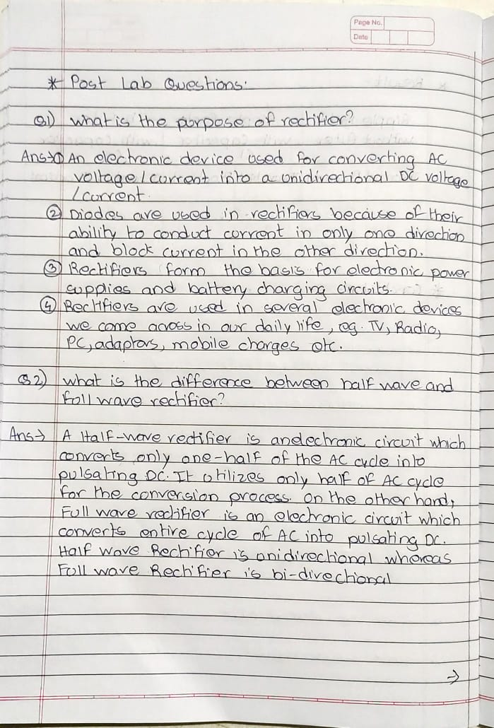

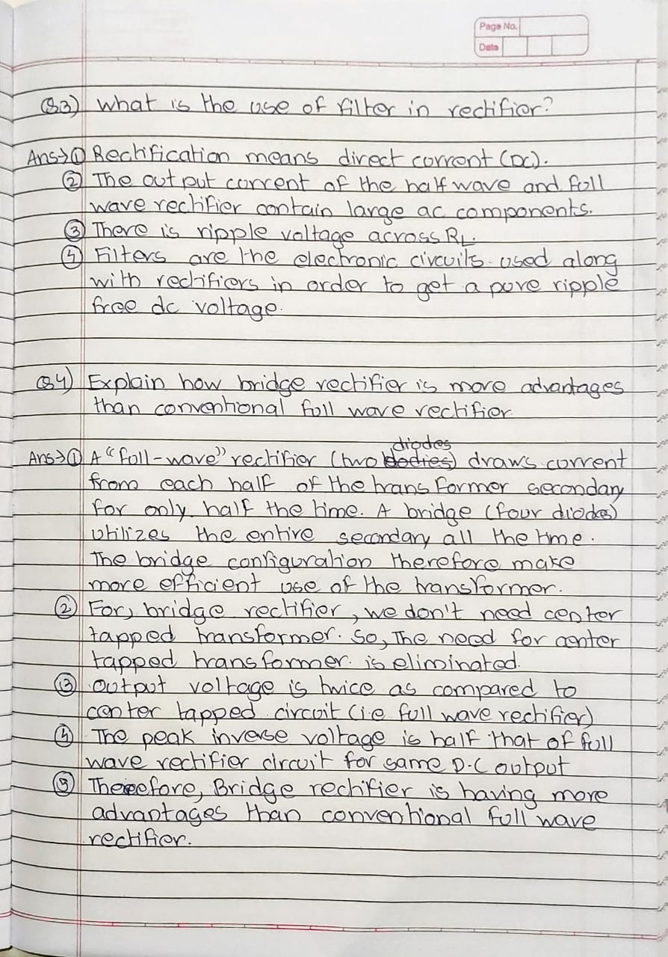

**Post Lab Questions:**

1. What is the purpose of rectifier?

2. What is the difference between half wave and full wave rectifier?

3. What is the use of filter in rectifier?

4. Explain how bridge rectifier is more advantages than conventional full wave rectifier.

**Additional links for more information:**

**●** http://vlabs.iitkgp.ernet.in/be/exp6/index.html

● http://vlabs.iitkgp.ernet.in/be/exp7/index.html

**F. Y. B. Tech Academic Year 2020-21 Trimester:I**

**SCIENCE & ENGG LABORATORY CONTINUOUS ASSESSMENT RUBRIC**

COURSE: BASICS OF ELECTRICAL AND ELECTRONICS ENGINEERING EXPT NO.: EVALUATOR: DATE:

STUDENT NAME:

|  |  |  |  |  |  |  |
| --- | --- | --- | --- | --- | --- | --- |
| **DIMENSION** | **SCALE** | | | | | **SCORE** |
| **1** | **2** | **3** | **4** | **5** |
| **Regularity and punctuality** | Did not Perform/ submit | Performed and submitted later than scheduled date with permission | Performed on schedule; submitted two weeks late | Performed on schedule; submitted one week late | Performed and submitted as per schedule |  |
| **Understanding the objective and Procedure** | Cannot follow the procedure and do any work | Follows procedure half-heartedly | Follows right procedure; but cannot analyze data and interpret it | Follows right procedure but can analyze data and interpret it | Follows right procedure; can analyze data and interpret it with justification |  |
| **P)articipation and Implementation Skills** | Does not participate in experiment | Performs the experiment only with the help from supervisor/others and is confused and untidy. | Performs the experiment with some supervisory help; but forgets some crucial reading and is confused and untidy. | Performs experiment on own without supervisory help; records all readings properly but untidy. | Performs experiment on his/her own without supervisory help; records all readings properly. Keeps the setup clean and tidy. |  |
| **Ethics** | Copies the results from others | Completes the result analysis with help from others but forgets to acknowledge the help. | Completes the result analysis with help from others and acknowledges the help. | Produces his own result analysis but blames others for any inadequacy found during the examination | Produces his own result analysis faithfully and owns up the results without any manipulation |  |
| Total | | | | | |  |
| Teacher’s signature with date: Student’s signature with date: | | | | | | |